PIZZA SALES ANALYSIS USING PGSQL QUERIES
- TOTAL REVENUE:
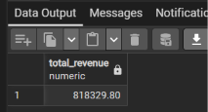
SELECT round (sum (total_price), 2) AS total_revenue FROM dd_dd_pizza_sales;

2. AVERAGE ORDER VALUE:
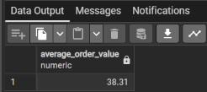
SELECT round (sum (total_price)/count (distinct order_id) ,2) AS Average_Order_value FROM dd_pizza_sales;

3. TOTAL PIZZA SOLD

SELECT sum (quantity) AS total_pizza_sold FROM dd_pizza_sales;
4. TOTAL ORDERS PLACED
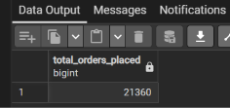
SELECT count (distinct order_id) AS total_orders FROM dd_pizza_sales;
5. AVERAGE PIZZAS PER ORDER
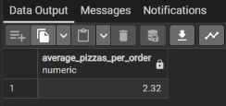
SELECT round(sum(quantity)::numeric /count(distinct order_id),2) AS average_pizzas_per_order FROM dd_pizza_sales;

EXTRA

6. TOTAL PIZZAS SOLD BY PIZZA SIZE

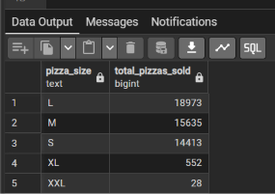
SELECT pizza_size, sum(quantity) AS Total_pizzas_sold FROM dd_pizza_sales
GROUP BY pizza_size
ORDER BY total_pizzas_sold desc;

DAILY TREND FOR TOTAL ORDERS

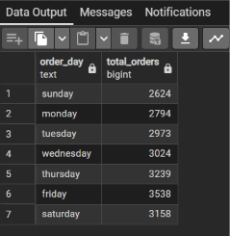

SELECT to_char(order_date, 'day') AS order_day,
COUNT (distinct order_id) AS total_orders FROM dd_pizza_sales
GROUP BY to_char(order_date,'day'), extract(dow FROM order_date)
ORDER BY extract (dow FROM order_date);

HOURLY TREND FOR ORDERS

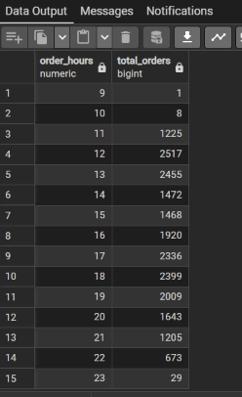
SELECT extract (hour FROM order_time) AS order_hours,
COUNT (distinct order_id) AS Total_orders FROM dd_pizza_sales
GROUP BY extract (hour FROM order_time)
ORDER BY order_hours ;

% OF SALES BY PIZZA CATEGORY

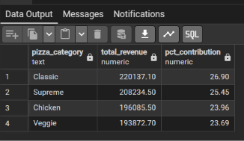
SELECT pizza_category, round(sum (total_price):: numeric, 2) AS total_revenue,
round ((sum(total_price)/(SELECT sum(total_price) FROM dd_pizza_sales) * 100):: numeric,2) AS PCT_contribution
FROM dd_pizza_sales
GROUP BY pizza_category
ORDER BY PCT_contribution desc;

% OF SALES BY PIZZA SIZE

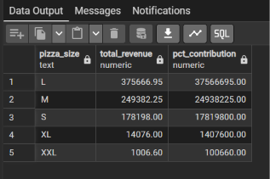

SELECT pizza_size, round(sum (total_price)::numeric, 2) AS total_revenue,
round ((sum(total_price) * 100):: numeric,2) AS PCT_contribution
FROM dd_pizza_sales
GROUP BY pizza_size
ORDER BY PCT_contribution desc;

TOTAL PIZZAS SOLD BY PIZZA CATEGORY
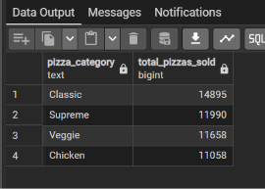
SELECT pizza_category, sum(quantity) AS total_pizzAS_sold FROM dd_pizza_sales
GROUP BY pizza_category
ORDER BY total_pizzas_sold desc;

TOP 5 BEST SELLERS BY TOTAL PIZZAS SOLD

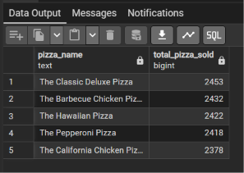

SELECT pizza_name, sum (quantity) AS total_pizza_sold FROM dd_pizza_sales
GROUP BY pizza_name
ORDER BY total_pizza_sold desc Limit 5;
BOTTOM 5 BEST SELLERS BY TOTAL PIZZAS SOLD

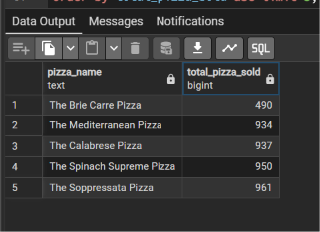
SELECT pizza_name, sum (quantity) AS total_pizza_sold FROM dd_pizza_sales
GROUP BY pizza_name
ORDER BY total_pizza_sold asc Limit 5;

